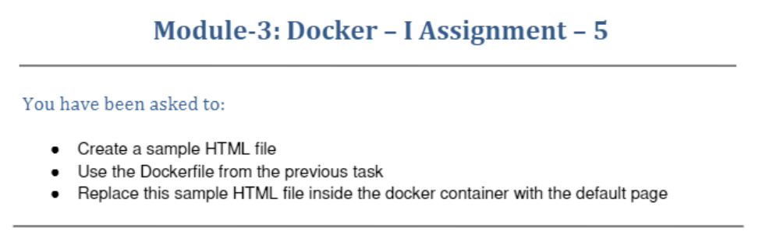
Dockerfile for assignment - 5
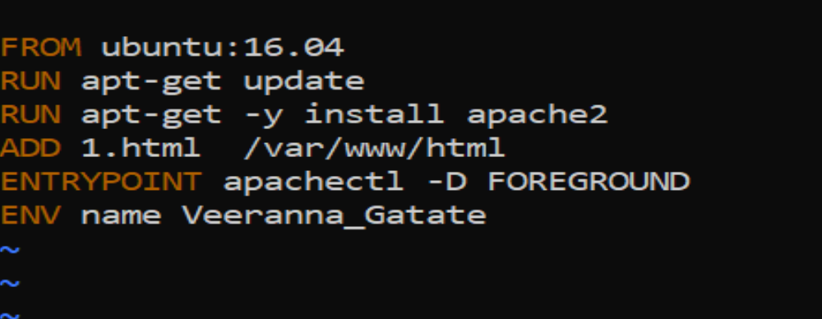
ubuntu@ip-172-31-39-74:~/dockerfile$ cd
ubuntu@ip-172-31-39-74:~$ cd dockerfile/
ubuntu@ip-172-31-39-74:~/dockerfile$ ls
1.html Dockerfile
ubuntu@ip-172-31-39-74:~/dockerfile$
ubuntu@ip-172-31-39-74:~/dockerfile$ sudo docker build . -t new_dockerfile
Sending build context to Docker daemon 3.072kB
Step 1/6 : FROM ubuntu:16.04
---> b6f507652425
Step 2/6 : RUN apt-get update
---> Using cache
---> bf05c22a886d
Step 3/6 : RUN apt-get -y install apache2
---> Using cache
---> a4753e6014a5
Step 4/6 : ADD 1.html /var/www/html
---> a5a7ce8b8982
Step 5/6 : ENTRYPOINT apachectl -D FOREGROUND
---> Running in 89a3425f548c
Removing intermediate container 89a3425f548c
---> 28a589c4fe23
Step 6/6 : ENV name Veeranna_Gatate
---> Running in 5964f2cac053
Removing intermediate container 5964f2cac053
---> 1dcd5a2224e3
Successfully built 1dcd5a2224e3
Successfully tagged new_dockerfile:latest
ubuntu@ip-172-31-39-74:~/dockerfile$

1.html file created
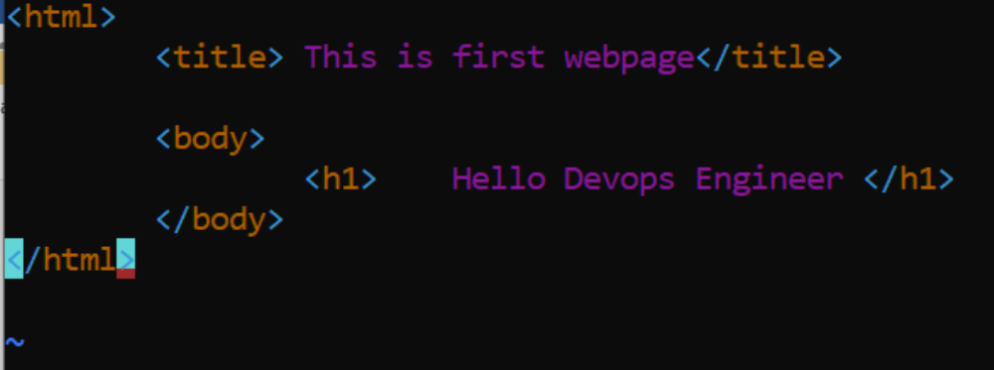

Accessing 1.html file after Dockerfile build
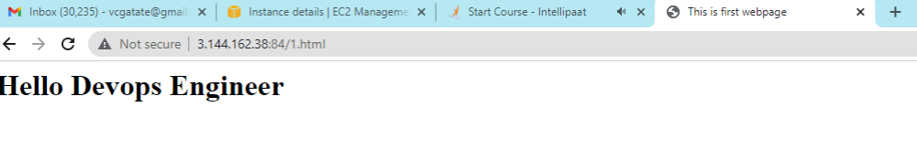

Accessing apache2 server after Dockerfile build

